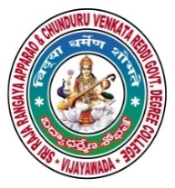 | SRR & CVR GOVERNMENT DEGREE COLLEGE  (AUTONOMOUS)  VIJAYAWADA, KRISHAN DIST., A.P  NAAC B+GRADE(CGPA:2.60) | 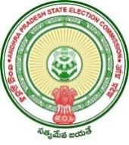

Sri Sri Jayanti
Date: 30-04-2022
- Sri Sri Jayanti celebrated on SRR & CVR college (A), Vijayawada

- Resource person: Vice Principal Dr. Sailaja, Hod’s and Lecturers .

- Chief Patron: Principal Dr. K.Bhagya Lakshmi.

- Events: poetry.

Srirangam Srinivasa Rao birthday popularly known as Sri Sri jayanthi was celebrated in SRR&CVR GDC(A) VJA. On this day principal Dr.K.BHAGYA LAKSHMI garu spoke about the Sri Sri history and his greatness as a poet and a lyricist. He worked for Telugu literature and films and was awarded “NANDI AWARD” and a “SAHITYA AKADEMI AWARD”. Some of the Telugu faculty members spoke about his contribution in Telugu poetry.
